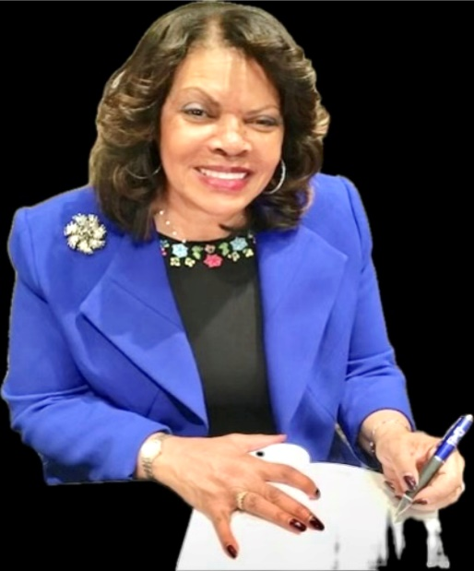
Dr. Hattie N. Washington
Dr. Hattie N. Washington is an internationally recognized educator, award-winning author, and pioneer in technology-driven learning. Over 30 years ago, she hosted the TV show, Computers for Kids, bringing tech literacy to underserved families across the DMV (DC, Maryland, and Virginia) before digital learning became mainstream. She launched after-school computer labs in empowerment-zoned churches and installed computer centers in her three foster boys' homes, aligning instruction with state standards, promoting critical thinking, and accommodating diverse learning styles.
A proud mother of two accomplished daughters—a physician and an attorney, she also reared scores of foster boys with special needs at a nonprofit she founded, Aunt Hattie’s Place, where she’s affectionately called “Aunt Hattie.” She inspired her first foster son to pursue a career in IT, who is now an IT specialist at Microsoft. Her career includes 25+ years as a model teacher, Assistant Superintendent of Baltimore Schools, and State Evaluator of Superintendents of Title I Schools, tenured Professor—training teachers, and first female Vice President at Coppin State University (CSU).
Dr. Washington holds a BS Degree in Elementary Education & Special Education; a Master’s in Counseling Psychology; and a Ph.D. in Curriculum Instruction. Further Study: Special Education & Multiculturalism, Glasgow University, Scotland, UK; Executive Leadership & Management, Harvard; & Innovation Techniques in Higher Education, London Roundtable. She is a certified AI/ChatGPT Specialist, a member of AAAI (Association for the Advancement of Artificial Intelligence), and is completing certification as an AI/EdTech Guru.
She is the author of four award-winning/best-selling books: AUNT HATTIE’S COOKBOOK: Southern Comfort Food Favorites; DRIVEN TO SUCCEED: An Inspirational Memoir of Lessons Learned Through Faith, Family, and Favor; and DETERMINADA A TRIUNFAR (DRIVEN translated into Spanish)--Partial proceeds from sales support Aunt Hattie’s Scholarship Fund (AHSF) to help with college expense for former foster youth aged out of care.
Her recent Amazon #1 Best-seller book, THE AI TOOLKIT FOR TEACHERS MADE EASY: 10 Simple Strategies To Save Time, Personalize Learning, And Empower Every Student To SUCCEED—Even If You’re Not Tech Savvy, empowers Teachers to help all students Believe, Achieve, and SUCCEED using innovation and technology. A 2018 inductee into the Maryland Women’s Hall of Fame, Dr. Washington continues to be a leading voice in empowering educators, parents, and students to succeed, now using aligned AI-powered tools. —visit: www.aitoolkit4teachers.ai or www.driven2succeed.com.

